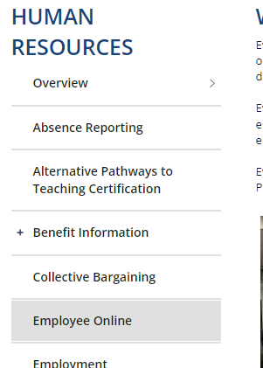
https://employeeonline.everett.k12.wa.us/employeeonline
DEPARTMENTS → HUMAN RESOURCES → EMPLOYEE ONLINE
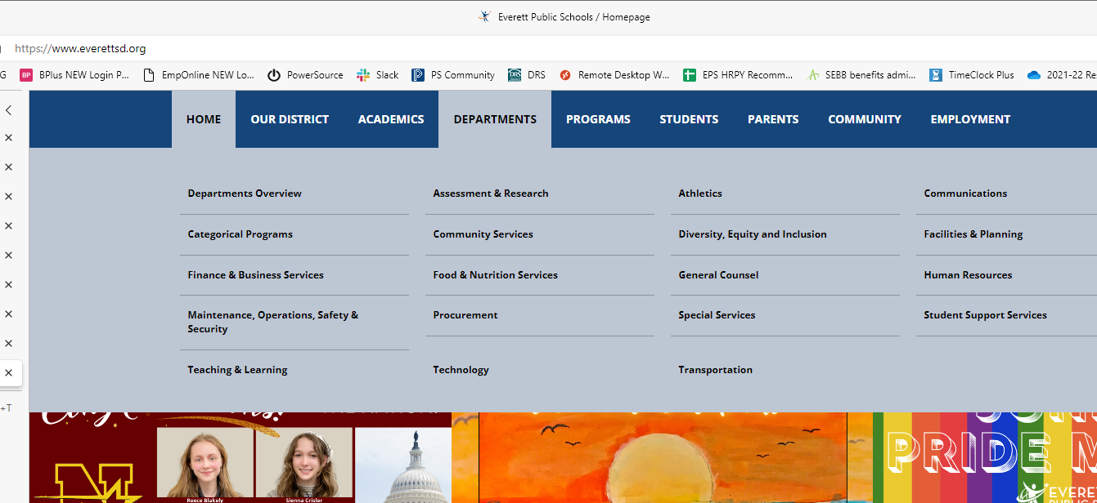

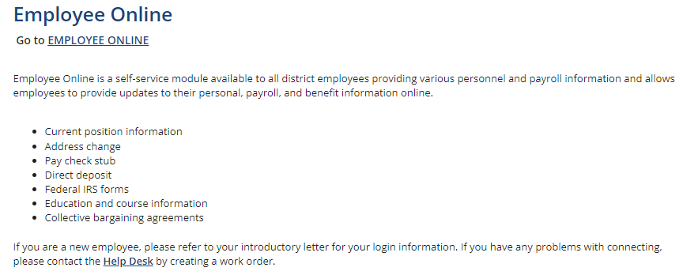
User and Password are the same as your district-issued network id (your employee id number) and password. If you do not have a district-issued network account, use your social security number (with no dashes) as your password.
